|  |  |
| --- | --- |
|  | **BAHRIA UNIVERSITY,**  **(Karachi Campus)**  *Department of Software Engineering*  **LAB ASSIGNMENT#02 – Fall 2020** |

COURSE TITLE: **Data Communication and Networking** COURSE CODE: **CEN-222**

Class: **BSE - 5** Shift:**Morning**

Course Instructor: **Engr. Mahawish Fatima** Marks: **5 Points**

Lab Instructor:**Engr. Fareeha Dilawar** Date:**18-Dec-2020**

Due Date: **24-Dec-2020**

**Kindly read the instructions:**

1. **This is an individual effort task.**
2. **Write your full name, registration number and section on the title page or in footer.**
3. **Upload it to LMS as a pdf file.**

Q1. Design a topology covering the following:

1. Your organization is having a max of 20 hop count.

2. You must cover a minimum of routing between four routers.

3. Information between one internal network is unknown to the other networks.

4. Default gateway is making decisions in the network.

5. Test your network and show the results.

**[CLO#1]**

**FOLLOW THE BELOW INSTRUCTIONS:**

1. **ATTACH OUTPUT SCREENSHOTS FOR EVERY COMMAND EXECUTION (EACH PART), FAILED TO DO SO WILL RESULT IN DEDUCTIONS**
2. **MAKE SURE TO ANSWER THE QUESTION AS PER THE PROCESSES, COMMANDS AND LOGICS STUDIED IN THE LAB.**
3. **ZERO PLAGARISM MEANS NO COPYING FROM THE INTERNET AND FFROM OTHERS (THE ONE WHO WILL COPY AND THE ONE WHO SHARES BOTH WILL FACE THE CONSEQUENCES).**
4. **TIMELY SUBMISSION IS IMPORTANT. FAILED TO DO WILL LEAD TO 3 MARKS DEDUCTION.**

**Good Luck!**

**Solution:**

Topology:

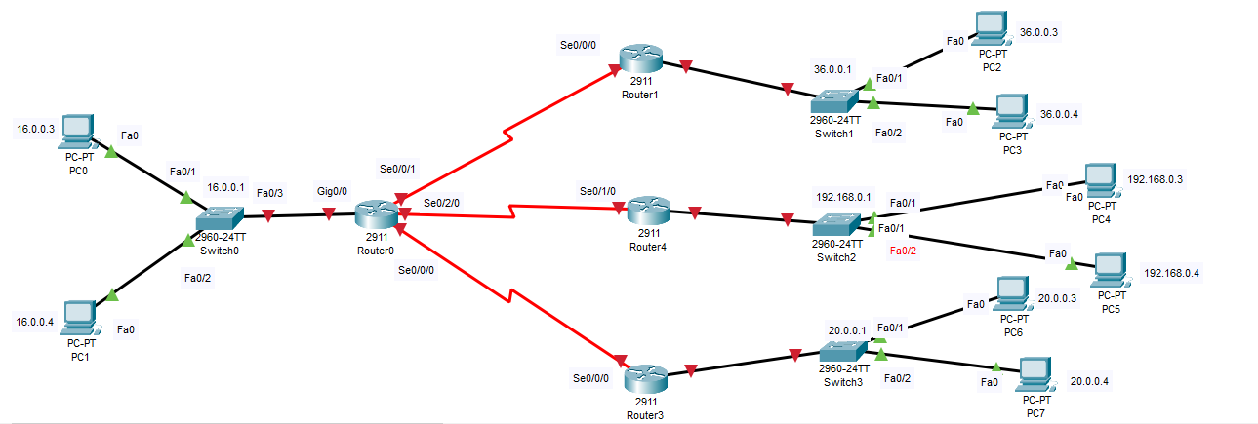

Availing extra ports on all routers:

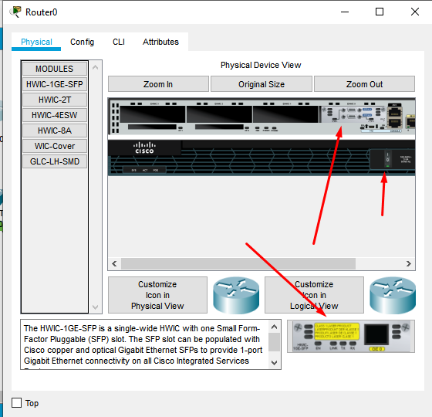

Adding default gateway and ip add. to every pc:

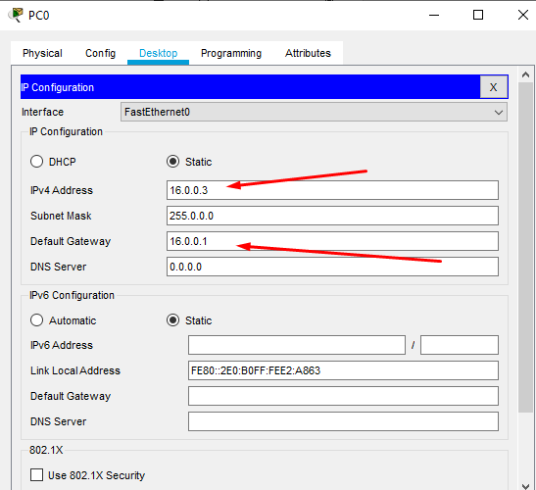

Router 0:

Router>en

Router#conf t

Enter configuration commands, one per line. End with CNTL/Z.

Router(config)#hostname R0

R0(config)#INT gig0/0

R0(config-if)#ip add 16.0.0.1 255.0.0.0

R0(config-if)#no shutdown

R0(config-if)#

%LINK-5-CHANGED: Interface GigabitEthernet0/0, changed state to up

%LINEPROTO-5-UPDOWN: Line protocol on Interface GigabitEthernet0/0, changed state to up

R0(config-if)#exit

R0(config)#int se0/0/1

R0(config-if)#ip add 12.0.0.3 255.0.0.0

R0(config-if)#clock rate 64000

This command applies only to DCE interfaces

R0(config-if)#no shut

%LINK-5-CHANGED: Interface Serial0/0/1, changed state to down

R0(config-if)#

R0(config-if)#exit

R0(config)#

R0(config)#int se0/2/0

R0(config-if)#ip add 13.0.1.3 255.0.0.0

R0(config-if)#clock rate 64000

R0(config-if)#no shut

%LINK-5-CHANGED: Interface Serial0/2/0, changed state to down

R0(config-if)#

R0(config-if)#exit

R0(config)#int se0/0/0

R0(config-if)#ip add 14.0.1.2 255.0.0.0

R0(config-if)#clock rate 64000

This command applies only to DCE interfaces

R0(config-if)#

R0(config-if)#n shut

%LINK-5-CHANGED: Interface Serial0/0/0, changed state to down

R0(config-if)#

R0(config-if)#exit

R0(config)#

Router 1:

Router>en

Router#conf t

Enter configuration commands, one per line. End with CNTL/Z.

Router(config)#hostname R1

R1(config)#int gig0/0

R1(config-if)#ip add 36.0.0.1 255.0.0.0

R1(config-if)#no shutdown

R1(config-if)#

%LINK-5-CHANGED: Interface GigabitEthernet0/0, changed state to up

%LINEPROTO-5-UPDOWN: Line protocol on Interface GigabitEthernet0/0, changed state to up

R1(config-if)#exit

R1(config)#int se0/0/0

R1(config-if)#ip add 12.0.0.4 255.0.0.0

R1(config-if)#clock rate 64000

R1(config-if)#no shut

R1(config-if)#

%LINK-5-CHANGED: Interface Serial0/0/0, changed state to up

R1(config-if)#exit

R1(config)#

%LINEPROTO-5-UPDOWN: Line protocol on Interface Serial0/0/0, changed state to up

R1#

%SYS-5-CONFIG_I: Configured from console by console

R1(config)#int se0/0/1

R1(config-if)#ip add 14.0.0.4 255.0.0.0

R1(config-if)#clock rate 64000

This command applies only to DCE interfaces

R1(config-if)#

R1(config-if)#no shut

%LINK-5-CHANGED: Interface Serial0/0/1, changed state to down

R1(config-if)#

R1(config-if)#

Router 4:

Router>en

Router#conf t

Enter configuration commands, one per line. End with CNTL/Z.

Router(config)#hostname R4

R4(config)#INT gig0/0

R4(config-if)#ip add 192.168.0.1 255.255.255.0

R4(config-if)#no shutdown

R4(config-if)#

%LINK-5-CHANGED: Interface GigabitEthernet0/0, changed state to up

%LINEPROTO-5-UPDOWN: Line protocol on Interface GigabitEthernet0/0, changed state to up

R4(config-if)#exit

R4(config)#int se0/1/0

R4(config-if)#ip add 12.0.0.5 255.0.0.0

R4(config-if)#clock rate 64000

This command applies only to DCE interfaces

R4(config-if)#no shut

R4(config-if)#

%LINK-5-CHANGED: Interface Serial0/1/0, changed state to up

R4(config-if)#exit

R4(config)#

R4(config)#int se0/1/1

R4(config-if)#ip add 14.0.0.6 255.0.0.0

R4(config-if)#clock rate 64000

R4(config-if)#no shut

R4(config-if)#

%LINK-5-CHANGED: Interface Serial0/1/1, changed state to up

R4(config-if)#

%LINEPROTO-5-UPDOWN: Line protocol on Interface Serial0/1/1, changed state to up

R4(config-if)#exit

R4(config)#int se0/3/0

R4(config-if)#ip add 14.0.0.8 255.0.0.0

% 14.0.0.0 overlaps with Serial0/1/1

R4(config-if)#ip add 19.0.0.8 255.0.0.0

R4(config-if)#clock rate 64000

This command applies only to DCE interfaces

R4(config-if)#no shut

%LINK-5-CHANGED: Interface Serial0/3/0, changed state to down

R4(config-if)#

R4(config-if)#exit

R4(config)#

R4(config)#

R4#

%SYS-5-CONFIG_I: Configured from console by console

Router 3:

Router>en

Router#conf t

Enter configuration commands, one per line. End with CNTL/Z.

Router(config)#hostname R3

R3(config)#int gig0/0

R3(config-if)#ip add 20.0.0.1 255.0.0.0

R3(config-if)#no shut

R3(config-if)#

%LINK-5-CHANGED: Interface GigabitEthernet0/0, changed state to up

%LINEPROTO-5-UPDOWN: Line protocol on Interface GigabitEthernet0/0, changed state to up

R3(config-if)#exit

R3(config)#int se0/0/0

R3(config-if)#ip add 12.0.0.6 255.0.0.0

R3(config-if)#clock rate 64000

R3(config-if)#no shut

R3(config-if)#

%LINK-5-CHANGED: Interface Serial0/0/0, changed state to up

R3(config-if)#

R3(config-if)#exit

R3#conf t

Enter configuration commands, one per line. End with CNTL/Z.

R3(config)#int se0/0/1

R3(config-if)#ip add 19.0.0.6 255.0.0.0

R3(config-if)#clock rate 64000

R3(config-if)#no shut

R3(config-if)#

%LINK-5-CHANGED: Interface Serial0/0/1, changed state to up

R3(config-if)#

R3(config-if)#exit

R3(config)#

**Configuration as per now:**

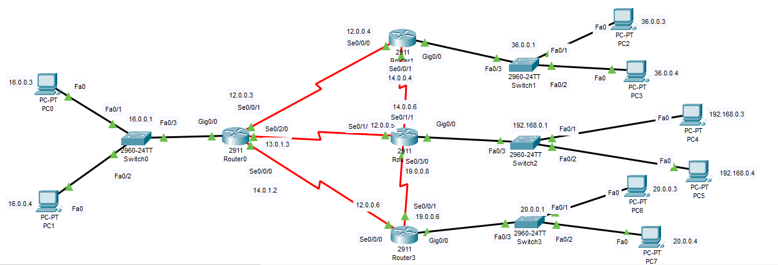

**Configuring OSPF routing on router 0:**

R0>en

R0#conf t

Enter configuration commands, one per line. End with CNTL/Z.

R0(config)#router ospf 1

R0(config-router)#network 16.0.0.0 0.255.255.255 area 1

R0(config-router)#network 12.0.0.3 0.255.255.255 area 0

R0(config-router)#network 13.0.1.3 0.255.255.255 area 0

R0(config-router)#network 14.0.1.2 0.255.255.255 area 0

R0(config-router)#exit

R0(config)#

**Configuring OSPF routing on router 1:**

R1>en

R1#conf t

Enter configuration commands, one per line. End with CNTL/Z.

R1(config)#router ospf 2

R1(config-router)#network 36.0.0.0 0.255.255.255 area 2

R1(config-router)#network 12.0.0.4 0.255.255.255 area 0

R1(config-router)#network 14.0.0.4 0.255.255.255 area 0

R1(config-router)#exit

R1(config)#

**Configuring OSPF routing on router 4:**

R4>

R4>en

R4#conf t

Enter configuration commands, one per line. End with CNTL/Z.

R4(config)#router ospf 3

R4(config-router)#network 192.168.0.0 0.0.0.255 area 3

R4(config-router)#network 12.0.0.5 0.255.255.255 area 0

R4(config-router)#network 19.0.0.8 0.255.255.255 area 0

R4(config-router)#exit

R4(config)#

**Configuring OSPF routing on router 3:**

R3>en

R3#conf t

Enter configuration commands, one per line. End with CNTL/Z.

R3(config)#router ospf 4

R3(config-router)#network 20.0.0.0 0.255.255.255 area 3

R3(config-router)#network 12.0.0.6 0.255.255.255 area 0

R3(config-router)#network 19.0.0.6 0.255.255.255 area 0

R3(config-router)#exit

R3(config)#

**Digital Ping test:**

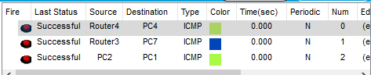

**Pinging from PC 0 to PC 4:**

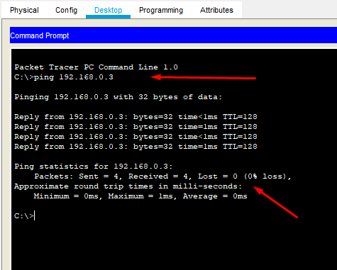

**Pinging from PC 1 to PC 2:**

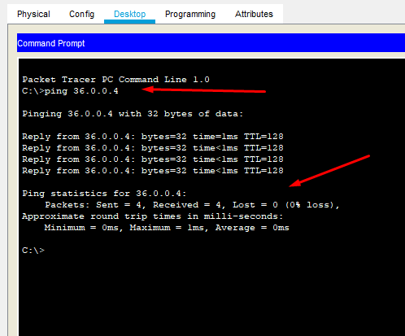

**Pinging from PC 6 to PC 0:**

